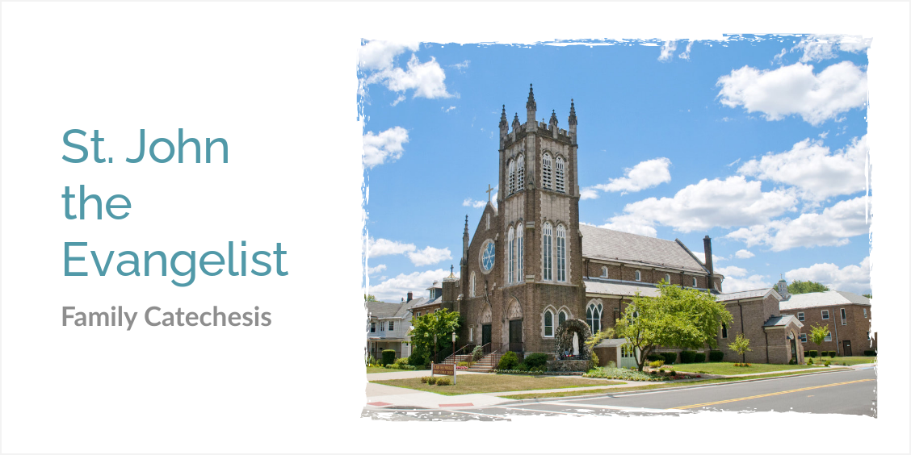
Sat., Jan. 13
8 to 12 noon
Time to
put the Christmas decorations away

A FAMILY OF FAITH
Jesus The Great Commandments and the First four Commandments.

VERSE OF THE MONTH:
“Know, then, that the LORD, your God, is God:
the faithful God who keeps covenant mercy to the thousandth
generation toward those who love him
and keep his commandments.” (Deuteronomy 7:9)

January Lessons
January in Review THIS MONTH YOU EXPLORED AS A FAMILY THE QUESTIONS:

How are the Ten Commandments a gift of God’s own self?
❏ Parent’s Guide: Moses Receives the Ten Commandments p. 114-115, Ten Commandments Tablets p. 122
❏ Activity Book: Moses Coloring Page p. 91, Ten Commandments Tablet p. 197

How does the First Great Commandment fulfill the first three commandments?
❏ Parent’s Guide: The First Commandment p. 116-117
❏ Activity Book: What Do I Do with My Day? p. 92
17 St. Anthony of the Desert / San Antonio del desierto
18 St. Margaret of Hungary / Santa Margarita de Hungría
20 St. Sebastian Martyr / San Sebastián Mártir
21 St. Agnes, Virgin and Martyr / Santa Inés, Virgen y Mártir
22 Day of Prayer for the Legal Protection of Unborn Children
St. Francis de Sales Story and Coloring Page (Spanish)
25 The Conversion of St. Paul / La conversión de San Pablo
28 St. Thomas Aquinas / Santo Tomás de Aquino
31 St. John Bosco / San Juan Bosco
Dates for January

How is the family a domestic church?
❏ Parent’s Guide: Ten Commandments Tablets p. 122, Keeping the First Three Commandments p. 123-124, The First Great Commandment and the First Tablet p. 126-127
❏ Activity Book: Ten Commandments Tablet p. 197, The First Great Commandment and the First Tablet p. 99

What can we learn from Jesus about how to live?
❏ Parent’s Guide: Gospel Matching p. 125
❏ Activity Book: Gospel Matching p. 97

LOOKING AHEAD
15 minute challenge – did you know taking 15 minutes a day to be with God is merely 1% of your day? Consider offering God 15 minutes of your time each day to grow closer to Him through scripture, silence, adoration, rosary, or just reading daily from your Family of Faith books.
January 2024
1 HOLY DAY – SOLEMNITY OF
MARY MOTHER OF GOD
7 11:30AM to 1PM Confirmation class
10:30AM Youth Mass
8 6:30PM to 8PM Parent meeting
1st Holy Communion Class
7th Grade class
9 6:30PM to 8PM Parent meeting
1st Holy Communion Class
7th Grade class
21 11:30AM to 1PM Confirmation class
22 6:30pm to 8pm 1st Holy Communion Retreat
28 9AM Community Meeting

CONTACTS and useful links and Apps

ALICE FOGARTY, PCL
Contact: stjohnpcl@gmail.com
Phone: 732 968 2621 Parish Center office
Bible app: Catholic Missal
This app can be helpful looking at bible, holy days, prayers, reading of the day, Bilingual, stations of the cross, mysteries
CC APP: CATECHISM OF THE CATHOLIC CHURCH
This app can be used to look up the (CCxxx)
references in Family of faith books
FIND MASS:
Find a mass near you when you are away
from home.
https://masstimes.org/

PARISH WEBSITE, FAMILY OF FAITH RESOURCES:
http://www.stjohnsdunellen.org/parent-meeting---monthly-resources.html
BULLETINS: http://www.stjohnsdunellen.org/bulletins.html
Adoration: Thursday, 8 am to 4pm in Parish Center Chapel
http://www.stjohnsdunellen.org/eucharistic-adoration.html
MASS TIMES:
Saturday 5 pm,
Sunday 8:30AM, 10:30am, 12 noon (Spanish),
Monday thru Friday 8:00am in Chapel at Parish Center
Tuesday, 7pm Spanish mass in Chapel
Penance: Saturdays 3:45 pm in Church

